**Tales of Harmonia: Website Redesign**

**Overview:**

The designer is required to develop a website to replace the current Wordpress Website. Detailed sketches, basic flow charts, and documentation will be required, and should list the main feature of the design, as well as how it addresses stakeholder concerns. The conceptual design is due by September 12th, 2013, and must be presented to an executive member.

**Background:**

The current website that the choir Tales of Harmonia utilises to communicate with both internal members and external organizations is a WordPress site using basic templates (Figure 1). While this serves the foundational needs of the choir, it does not serve to promote a professional image of the choir to both members and non-members.

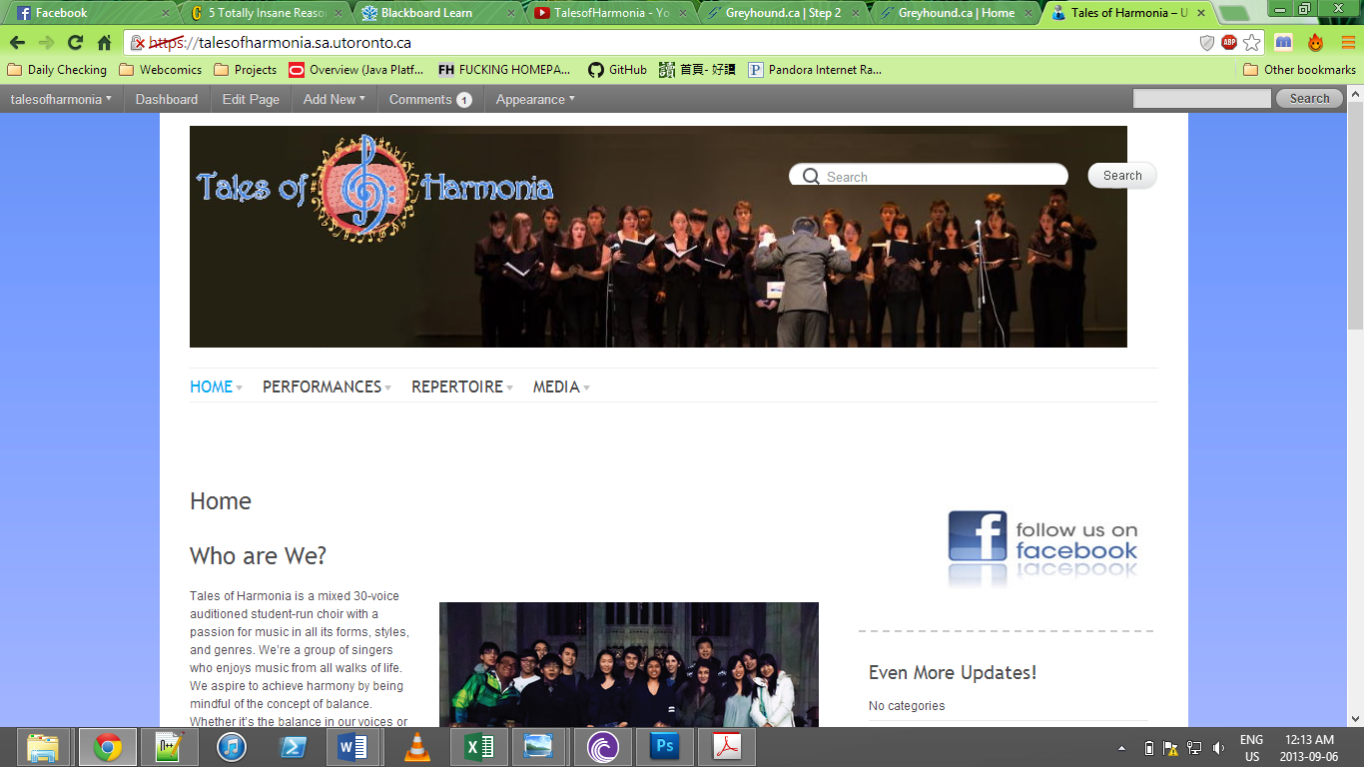

*Figure 1: A screenshot of the current website in administrator mode.*

In comparison, other student groups (e.g. TBA, Hart House Chorus) have professional websites *(Figure 2)*, which are able to enhance their public image, promoting themselves to internal and external entities.

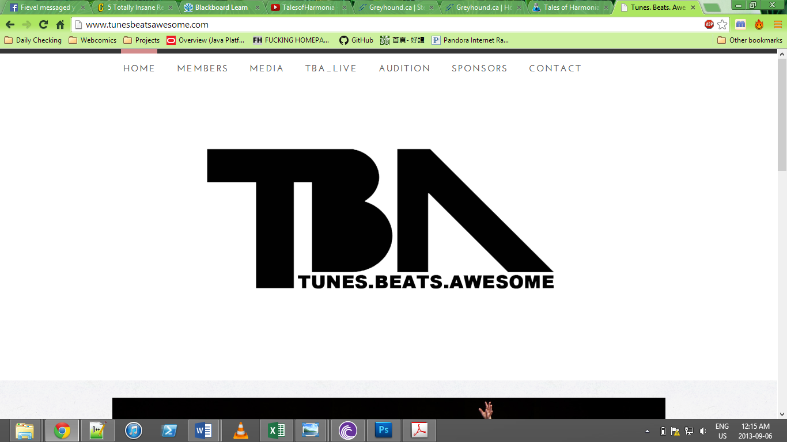

*Figure 2: A screenshot of the website of a capella group Tunes. Beats. Awesome.*

By examining other websites, it is clear that our current website lacks the polish necessary to be more than a basic tool for the choir.

**Problem Definition**

It can be seen from the various examples that the current website lacks the professionalism that could easily be obtained. The designer is tasked with creating a website that helps promote the professional image of the choir, retains or increases the functionality with respect to the previous website, and cater to the stakeholders of this project.

**Stakeholders**

1. **Current Executive Members**

* Executive members have a say in the major decisions of the choir, including the digital face of the choir – as a result, their decision directly influences the outcome of the website

1. **Future Executive Members**

* The longevity of the website depends on passing the maintenance of the website on to the next webmaster.

1. **Members**

* One of the main functions of the website is to provide media and information to the members of the choir, and its success hinges upon this

1. **Potential Members**

* The website should provide a clear image of the choir to people wishing to join, and give a good first/second/nth impression of the choir to them.

1. **External Organizations**

* A major reason for the redesign is to improve the image of the choir – if external entities dislike the website, then the redesign fails.

**Objectives**

* Provide a professional image of the choir (1,4,5)
* Retain or increase functionality in respect to the current website (1,3)
* Be easily maintainable (2)

**Constraints** the design must follow.

* Must stay within the server limits of ULife hosting (check)
* Must be feasibly made within a short period of time
* Must be multi-platform (work on all browsers + be mobile compatible)

**Criteria** the design will be assessed on.

* The maximum number of pages required to access the most obscure page (less is better)
* The adherence to a set colour scheme (Less variance is better)
* The number of pages (less is better)
* The number of tools required to maintain it (less is better)
* The graphic elements utilised (1 focused graphical element per page)
* The fonts used (less variance from chosen fonts is better)